A3 – Power Supply
For this workshop task, we needed to take our Raspberry-Pi power supply and cut the cable, so that we could solder it back together and shield it with multiple heat shrinking tubes.
However, our workshop teachers decided against it since it is risky to do so and it is costly to replace said power supply, so we used a simple electrical power cable and did the same tasks on said power cable.

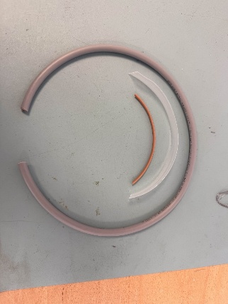
Preparation

For this task, we were given a power cable, a small heat shrinking tube, a big clear heat shrinking tube and a cable of solder.

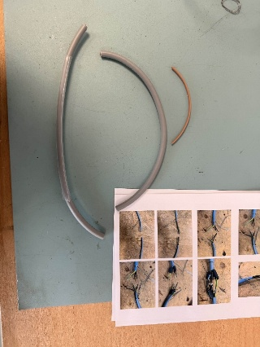
Step 1: Cutting the cable

Our first step was cutting the cable into two so that we can solder them with more ease. To do so we used a wire cutter and cut the cable in half.

Step 2: Stripping the outer insulation
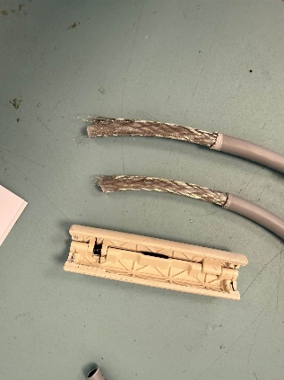
Secondly, we had to strip the outer insulation so that we could access the braided metal mesh, which is used to protect against magnetic frequencies. To do so, we used a wire stripper, and we had to be careful to not nick the inner wires or said metal mesh.

Step 3: Exposing and preparing the shielding
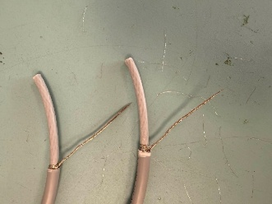
Thirdly, we had to spread the metal mesh as to expose the inner insulated wires. To do so, we simply pulled to metal mesh back and then we twisted the mesh together, so that it’s easier to solder the cables.

Step 4: Stripping the inner insulation
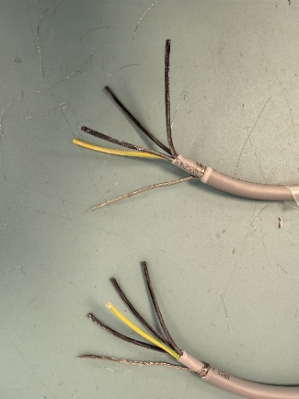
Fourthly, we had to strip the inner insulation, so that we have the cables visible. To do so, we used a wire stripper as mentioned in the first step. However, we do need to be careful since there is a white powder inside the insulation which prevents the cables from having water being inside of them. Make sure to not have any power go into your eyes, since it will dry your eyes out.

Step 5: Stripping the wires
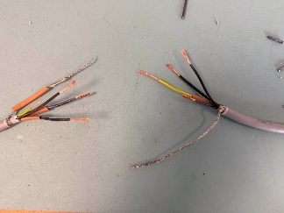
Fifthly, with the wires exposed, strip a small section of insulation at the end of each wire and be careful to not cut or nick any copper conductor. After stripping the insulation, twist the copper so that they won’t split when soldering them together.

Step 6: Soldering the connections
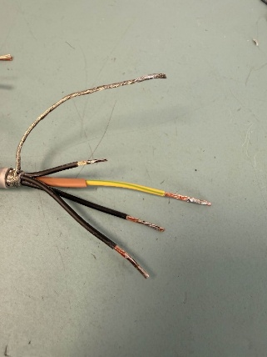
Sixthly, we are going to start soldering the connections together. Slide a small heat shrinking tube on each wire afterwards, check the wires for which number it has, then solder the opposed wire with the same number together.

Step 7: Insulate and protect
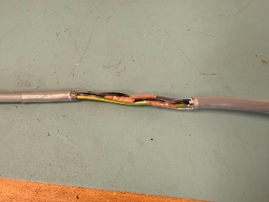
Seventhly, we must slide the small shrinking tubes over the exposed wires and use a hot air gun to heat the shrinking tubes, so that they shrink and insulate the exposed conductors. Once done, we slide the clear shrinking tube over the wires and once again heat it up, to insulate the wires.

Conclusion
We had to cut a cable into two, so that we could test our ability to strip cables without damaging the inside wires and metal mesh. Also to test our ability to solder the correct wires together and to insulate the cables again using heat shrinking tubes.

